**Java SE Project**

YumXpress Application

***CustomerRegisterFrame Documentation***

1. **CustomerRegisterFrame–**

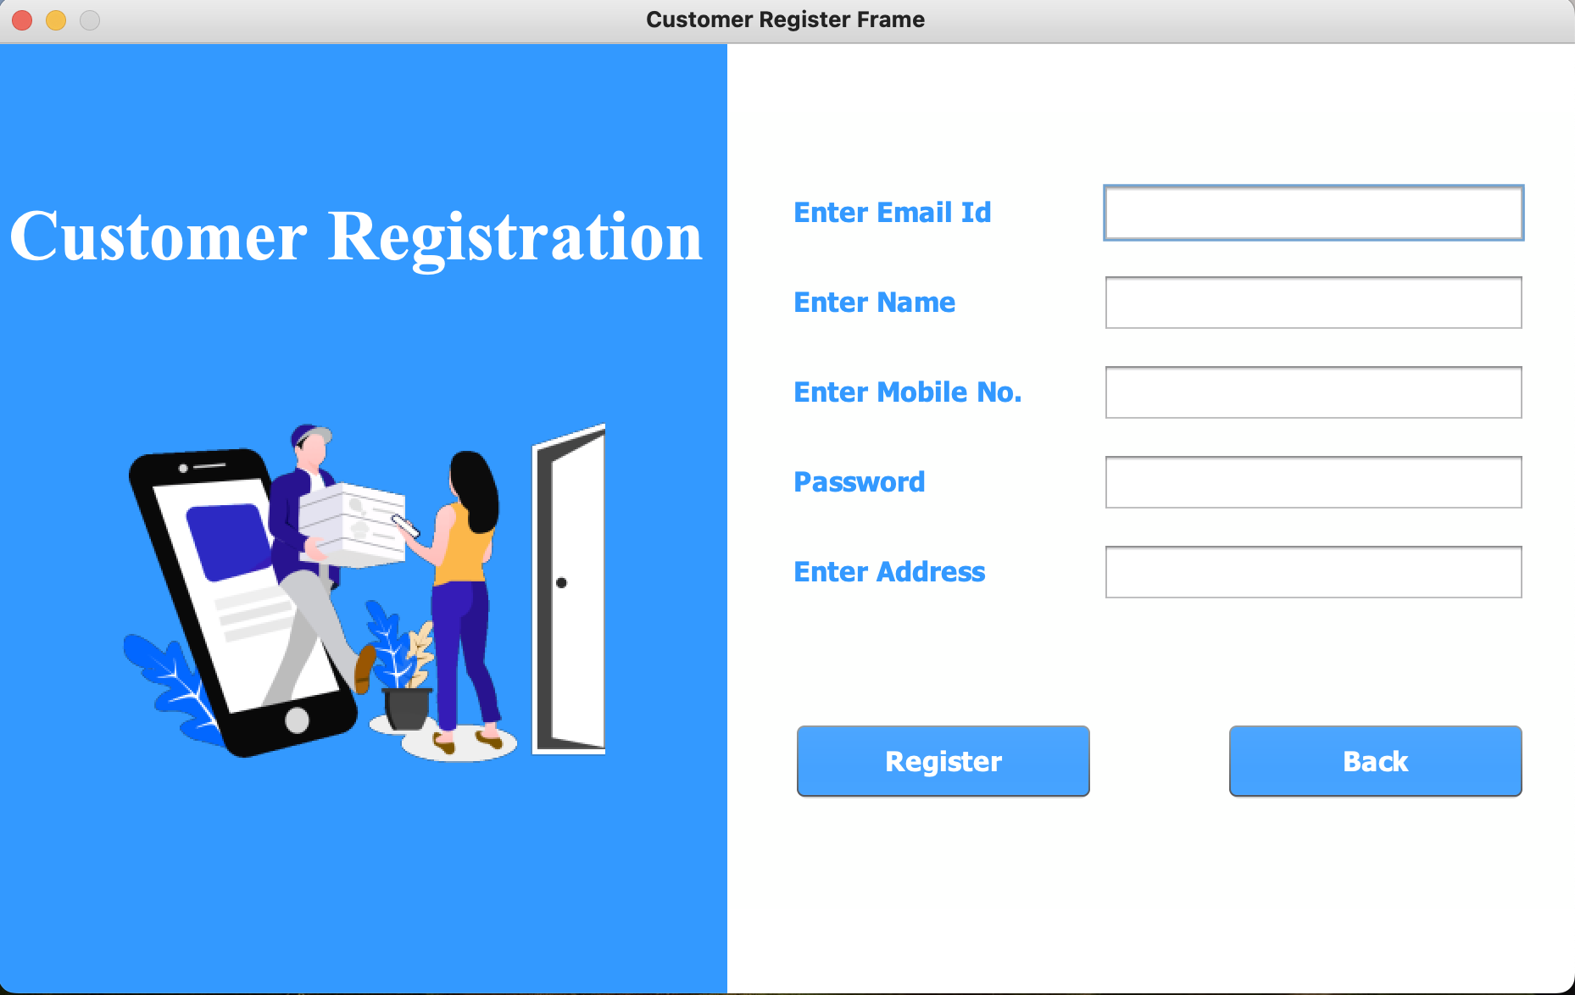

**2. STEPS TO BE DONE INCustomerRegisterFrame**

In the **CustomerRegisterFrame** we need to do following steps:

1. **Creating The Customers Table**
2. **Creating CustomerPojo**
3. **Creating CustomerDAO with 2 methods: getNewId() and addCustomer()**
4. **Define a method called sendMail() in Mailer class for sending Welcome Email to customer with account details.**
5. **In the Validator class we need 2 methods isValidEmail() and isValidMobileNo() for validating email and mobile no entered.**
6. **In the CustomerRegisterFramewe need to define following methods:**

**validateInputs()**

* + - 1. **Event handler for Register button**
      2. **Event handler for Back button**

**Query of creating table :**

**CREATE TABLE CUSTOMERS (**

**CUSTOMER_ID VARCHAR2(10) CONSTRAINT CUSTOMERS_PK PRIMARY KEY,**

**CUSTOMER_NAME VARCHAR2(50),**

**EMAIL_ID VARCHAR2(30) CONSTRAINT CUSTOMERS_EM_NN NOT NULL,**

**PASSWORD VARCHAR2(20),**

**MOBILE_NO VARCHAR2(10),**

**ADDRESS VARCHAR2(150),**

**);**